**ADVENTORI CAMPAIGN - FIRST INTERVIEW WITH MEDIA AGENCY / ADVERTISER**

1. Presentation of the advertiser and his needs
2. Campaign Category? Main Goals and KPIs of the campaign?

□ Branding

□ Acquisition

□ Retargeting *

□ Web-to-store *

□ CRM Display / Contextualization *

□ Adserving / Tracking

***\** *Note !***

*\*For Retargeting: ADventori will need to Tag the Advertiser website. It requires more time for the campaign setup (10 days minimum), and the availability of the Webmaster / Technical contact on the advertiser side, to implement Tags and test them with us before the launch of the campaign. Retargeting Scenarios must be precisely defined by the advertiser before the campaign (which product(s) to display: viewed products? Same category? Top-products?). CONTACT THE ADOPS TEAM ASAP (op@adventori.com )*

*\*For Web-to-store: ADventori will need the list of the stores / retailers, with their addresses, and latitude / longitude. It can be an Excel file. Web-to-store Scenarios must be precisely defined by the advertiser before the campaign (which distance must be set between the store / retailer and the user?). CONTACT THE ADOPS TEAM ASAP (op@adventori.com )*

*\*For CRM Display: What are the Datas from the advertiser provided to ADventori? Which format is available for this Data? Which source?*

1. Campaign Type?

□ DCO

□ Product Display (Carousel?)

□ Retailer Display (Carousel?) *

□ Landing Page / Store Locator *

□ Location-based *

□ Weather-sensitive *

□ Other Situational Data Feeds (Sports, Pollution, News, Traffic, Social Medias, etc.) *

□ Multi-language / International

□ Multi-variant

□ Data-Driven (CRM, etc.)

***\** *Note !***

*\*For Retailer Display, Landing-Page / Store Locator, and Location-based: ADventori will need the list of the stores / retailers, with their addresses, and latitude / longitude. It can be an Excel file. Web-to-store Scenarios must be precisely defined by the advertiser before the campaign (which distance must be set between the store / retailer and the user?). CONTACT THE ADOPS TEAM ASAP (op@adventori.com )*

*\*For Weather-sensitive and Other Situational Data Feeds: Scenarios must be precisely defined by the advertiser before the campaign (what will be the messages (CTA / Images) for each situation case?).*

*\*For Data-Driven: What are the Datas from the advertiser provided to ADventori? Is there a DMP to plug? It requires more time for the campaign setup (10 days minimum), and the availability of a Technical contact on the advertiser/DMP side, to plug and test the integration with us before the launch of the campaign. CONTACT THE ADOPS TEAM ASAP (op@adventori.com )*

1. Type of Display?

□ Desktop

□ Mobile *

□ Tablet *

□ IPTV

□ DOOH *

***\** *Note !***

*\*For Mobile, Tablet: It requires more time for the campaign setup (7 days minimum), to test all devices. It is even more true with Video Ads (VAST/VPAID). Some Trackings are only available in consideration of the Publishers Technical Specifications (Viewability for example): Come back to the Dev and AdOps teams as soon as possible for more info.*

*\*For DOOH: Come back to the Dev and AdOps teams as soon as possible for warning. Setting up DOOH Ads requires more time for testing. CONTACT THE ADOPS TEAM ASAP (op@adventori.com )*

1. Type of Ads?

□ IAB

□ Rich-Media *

□ Skins *

□ Video *

□ Native Ads *

***\** *Note !***

*\*For Rich-Media, Skins, Video and Native Ads: It requires more time for the campaign setup (7 days minimum), to test the campaign with the Publishers websites. CONTACT THE ADOPS TEAM ASAP (op@adventori.com )*

1. Additional Setup needs

□ DMP / Data Feeds Plugging *

□ Advertiser Site Tagging / Scrapping *

□ Additional dynamic Tracking (3rd Party)

□ Integration / Certification / Tests with Publishers / Trading-Desks / Creative Agencies *

***\** *Note !***

*\*For DMP / Data Feeds Plugging: It requires more time for the campaign setup (10 days minimum), and the availability of a Technical contact on the advertiser/DMP side, to plug and test the integration with us before the launch of the campaign. CONTACT THE ADOPS TEAM ASAP (op@adventori.com )*

*\*Fo*r *Advertiser Site Tagging / Scrapping: It requires more time for the campaign setup (10 days minimum), and the availability of the Webmaster / Technical contact on the advertiser side, to implement Tags and test them with us before the launch of the campaign. CONTACT THE ADOPS TEAM ASAP (op@adventori.com )*

*\*For Integration / Certification / Tests with Publishers / Trading-Desks / Creative Agencies: It requires more time for the campaign setup (10 days minimum), and the availability of a Technical contact from the Publisher / Trading-Desk / Creative Agency, to be certified. CONTACT THE ADOPS TEAM ASAP (op@adventori.com )*

1. Schedule of the campaign / Start Date? End Date?

□ One-Shot campaign

□ Event-based / Special Operation (Schedule constraints)

□ Always-On campaign

***\** *Note !***

*\*If the time limits wanted by the Media Agency / Advertiser seems too short (less than 5 days), come back to the AdOps team as soon as possible for warning and validation of the feasibility of the campaign. CONTACT THE ADOPS TEAM ASAP (op@adventori.com )*

1. Volumes of Impressions?

□ CPM ……………….. impressions

□ CPC ……………….. clicks

□ CPA / CPL ……………….. actions / leads

1. Tracking / Statistical Reports

□ Classic (Impressions / Clicks / CTR) *>NEED: PIXELS + CLIC-COMMANDS*

□ Additional Creative Tracking (CTA / Images) * *>No additional elements required*

□ Products / Retailers Tracking * *> No additional elements required*

□ Situational Tracking (Location / Weather / Others) *  *>No additional elements required*

□ CRM / User Tracking * *>WHAT KIND? (Google Analytics / etc.?)*

□ Additional dynamic Tracking (3rd Party) * *>WHAT KIND? (Eulerian / Omniture / Alenty/ etc.?)*

□ Viewability * *> No additional elements required*

□ Attribution * *> No additional elements required*

***\** *Note !***

*\*For Additional Creative Tracking, Products / Retailers Tracking, Situational Tracking, and CRM / User Tracking: The needs of the Media Agency / Advertiser must be precisely defined by the advertiser before the campaign, to allow ADventori to forecast them. New non-anticipated demands after the launch of the campaign will be too late and impossible to provide.*

*\*Fo*r *Additional dynamic Tracking, Viewability and Attribution: Come back to the AdOps team as soon as possible for warning and validation of the feasibility. CONTACT THE ADOPS TEAM ASAP (op@adventori.com )*

|  |  |
| --- | --- |
| **ADVENTORI CAMPAIGN – INFORMATIONS REQUIRED** | |
|  |  |
| **GENERAL INFO REQUIRED** | **Please fill in each entry during your brief** |
| Name & Contact of the person leading the project |  |
| Advertiser / Website |  |
| Campaign Category (Acquisition / Retargeting / WTS / etc.) |  |
| Campaign Goals and KPIs (needed for Stat reports and setup) |  |
| Campaign Type (DCO / Product Display / Retailer Display / etc.) |  |
| Type of Display (Desktop / Mobile / Tablet / etc.) |  |
| Type of Ads (IAB / Rich Media / Skins / Video / etc.) |  |
| Launch / End dates of the campaign |  |
| Estimated volumes |  |
| Countries covered by the campaign |  |
| Types of tracking to implement |  |
| Redirection URL if no tracking has been implemented by ADventori |  |
| Scenarios description regarding Campaign Category |  |
| DMP used? |  |
|  |  |
| **MAIN ELEMENTS REQUIRED** | **Please fill in each entry during your brief** |
| Media Plan: Placements / Networks / Dates / Volumes / Ad Sizes |  |
| Technical Specifications of Networks / Publishers / Adservers |  |
| Who's in charge of the banner creation? Creative Studio contact info |  |
| HTML5 / Video Banners (fonts, images, etc.) + Backup GIF |  |
| Tracking Elements |  |
| Signed Order Form before the Launch of campaign |  |
|  |  |
| **CREATIVES INFO REQUIRED** | **Please fill in each entry during your brief** |
| Screenwriting of animations |  |
| Dynamic elements to display (product names, prices, location, weather, images, etc.) Carousel or not? |  |
| Technology used (Adobe Edge / Google Web Designer / From scratch?) |  |
| Creative Studio Contacts List |  |
|  |  |
| **RETARGETING + SCRAPING CAMPAIGN - REQUIRED INFO** | **Please fill in each entry during your brief** |
| Presence of a Product Feed + What does it contain? DMP availability? |  |
| Need of Scraping? (If No Product Feed available) |  |
| Need of Tagging Advertiser website? Presence of a tag container? |  |
| Technical Contacts List |  |
| Pages List to implement the Retargeting Tags |  |
| Optional: Pages List to implement the Scraping scripts + Info to retrieve |  |
|  |  |
| Definition of Top products list? Related products? Products of same category? |  |
| Definition of a "No Data" scenario |  |
|  |  |
| **DRIVE-TO-STORE + LOCAL PAD / LANDING PAGE CAMPAIGN – REQUIRED INFO** | **Please fill in each entry during your brief** |
| Sending the Retailers listing file |  |
| Wording to implement + backup wording |  |
| CTAs to implement for the Local Pad / Landing Page |  |
| Sending creative elements for the Local Pad / Landing Page (fonts, logos, colorimetric values, images, texts, etc.) |  |
| Local Pad tracking elements |  |
| Creation and implementation of the CNAME (client side + needs to be sent to ADventori) |  |

|  |  |
| --- | --- |
| **DMP / DATA FEED PLUGGING – INFO REQUIRED** | **Please fill in each entry during your brief** |
| What kind of DMP? / Name of the DMP |  |
| What does it contain? Info needed for the campaign: availability? |  |
| Technical Contacts List |  |

|  |
| --- |
| **GENERIC INFO TO PROVIDE FOR BANNER PRODUCTION** |
| Our Technical Specifications for HTML5/CSS Creatives (ADventori Enabler integration, clickTag, dynamic wordings and images, text-adapt, image-adapt, carousels, etc.):  <https://www.adventori.com/be-inspired/create-your-dynamic-ads/dco-enabler-html5-v2/>  [https://www.adventori.com/be-inspired/create-your-dynamic-ads/](https://www.adventori.com/be-inspired/create-your-dynamic-ads/dco-enabler-adobe-edge/) |
| + More guidelines concerning ADventori Banners Creation with Adobe Edge :  <https://www.adventori.com/be-inspired/create-your-dynamic-ads/dco-enabler-adobe-edge/> |
| + More guidelines concerning ADventori Banners Creation with Google Web Designer:  <https://www.adventori.com/be-inspired/create-your-dynamic-ads/dco-enabler-google-web-designer/> |
| + ADventori Test Page for testing the creatives. Creative Studio can use it anytime to check them:  <http://bov3.adventori.com/testPage/test> |
| Provide the Creative Studio with our contacts *(op@adventori.com )*. |

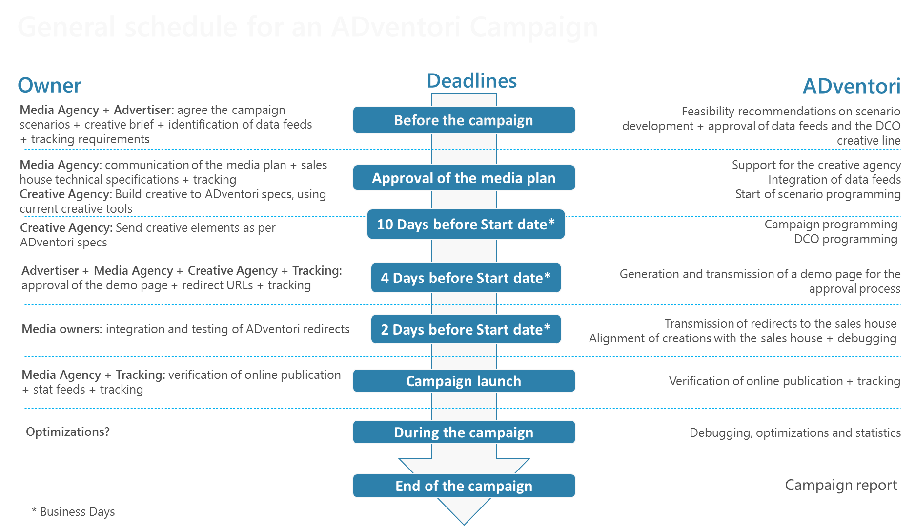

General Schedule for an ADventori Campaign